**MAD Lab Mid:**

**Submitted To:**

**Sir Abdullah**

**Submitted By:**

**M Faisal Nawaz**

**(FA19-BCS-064)**



GIT HUB Link:

<https://github.com/faisal2363/POCKET_PASSWORD_APP>

ScreenShots:

1. Splash Screen:

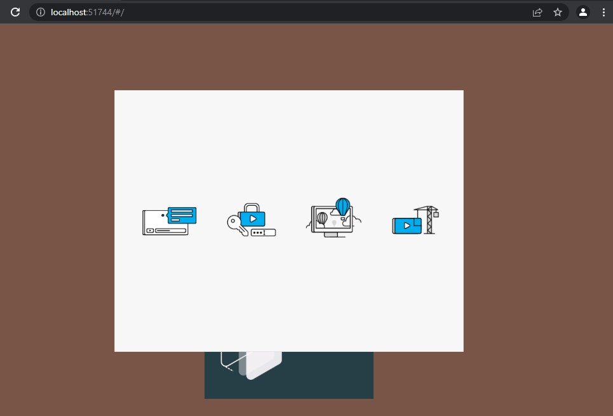

2.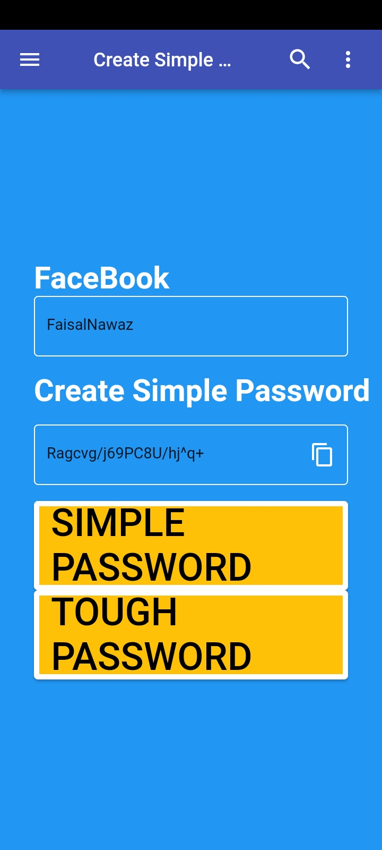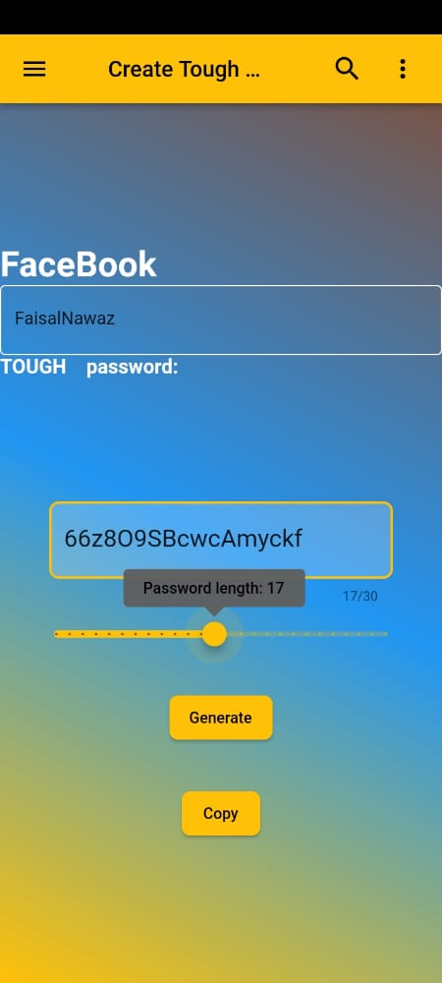ss